1 : Explication d’idée

2 : what we need to complete the project with success

AI Side : face recognition model, Rasepery Pi 4 with camera sensor and RFID Reader

Database Side : MYSQL , API that allows communication between the Arduino and the Web Application

Web Application : Explication

Languages and frameworks : python(To be decided), PHP and MYSQL ( Symfony for the web app and also the API the backend side) Dashboard template (VELZON) for the front end side .

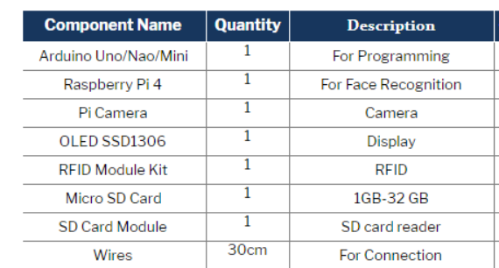

Libraries that we need :

* Ug82 Oled library
* MFRC522

After that, setup the following libraries for Python:

* Serial
* Dlib
* Cv2
* Face recognition opencv